# 2. Data

**Data Processing**

For data processing, I have gathered the data from number of injuries from year 2004 to 2013 of each type of road users. The data attributes that I have taken from the data source are type of users, years, age groups, number of road traffic injuries, genders, and number of injuries in states.

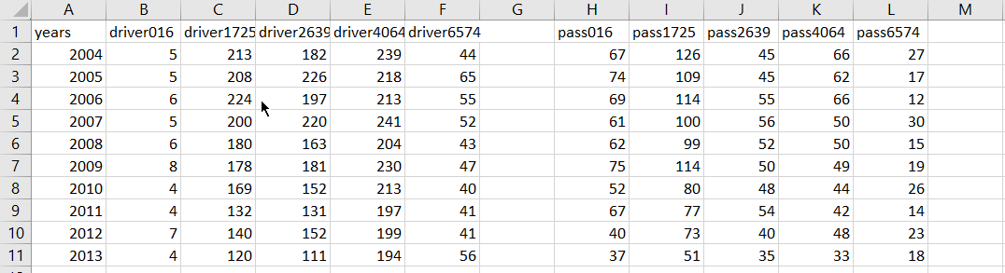

figure : example of data processing progress

The figure above shows the data of deaths by road users and age group. I have combined type users and age group in order to make the data visualisation more comparable. It shows the year from 2004 to 2013 and number of deaths by road users and age groups. There are 5 type of road users which are drivers, passengers, pedestrians, motorcyclists, and pedal cyclists. And also, there are 5 age groups have been collected from the reliable source which are 0-16 year old, 17-25 year old, 26-39 year old, 40-64 year old, and 65-74 year old.

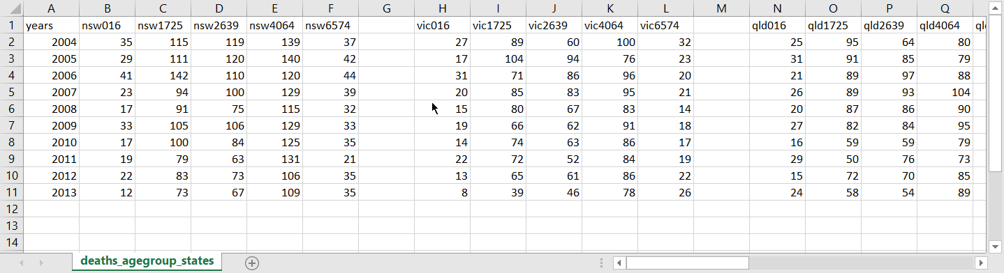

figure : example of data processing progress 2

The figure above shows the data of deaths by road users and state. I have combined type users and states. I took the data from 2004 to 2013 and number of deaths by states and road users and convert it to csv file.

# 4. Visualisation Design

The design still remain unchanged. I have created a simple prototype to make sure the value from csv file can be read and display. The prototype is multiple line graph which shows the number of deaths by road users and age group. Each line shows the each type of road users and there has a group of ratio button to change the type of road users. I have also implemented labels for y-axis and x-axis.

For next improvement, I plan to do line transition when changing categories of road users. Furthermore, I also plan to do legend area to tell users the meaning of the lines’ colour.

# Appendix A

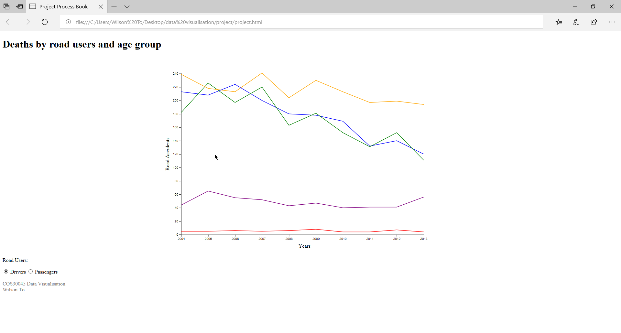

figure 3: prototype 1

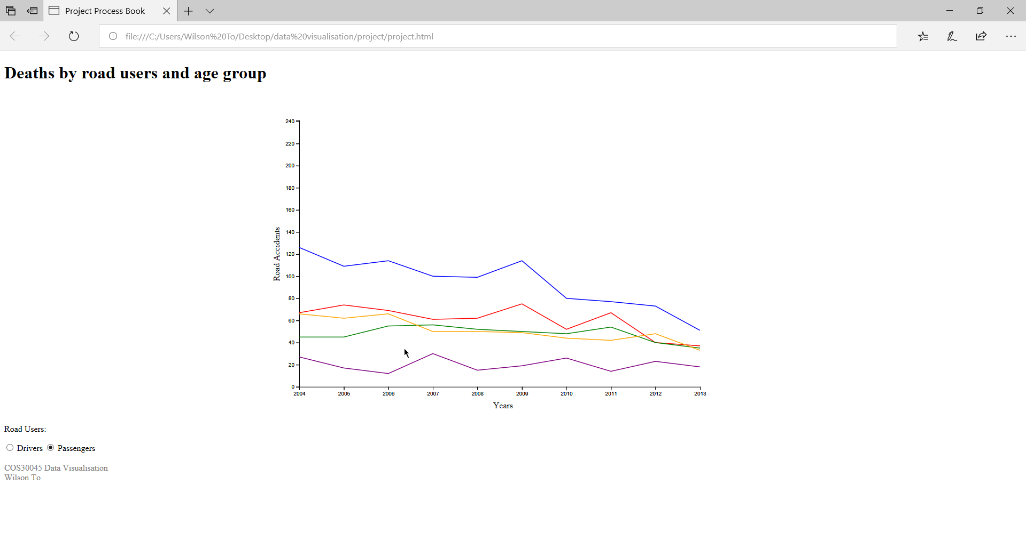

figure 4: prototype 2

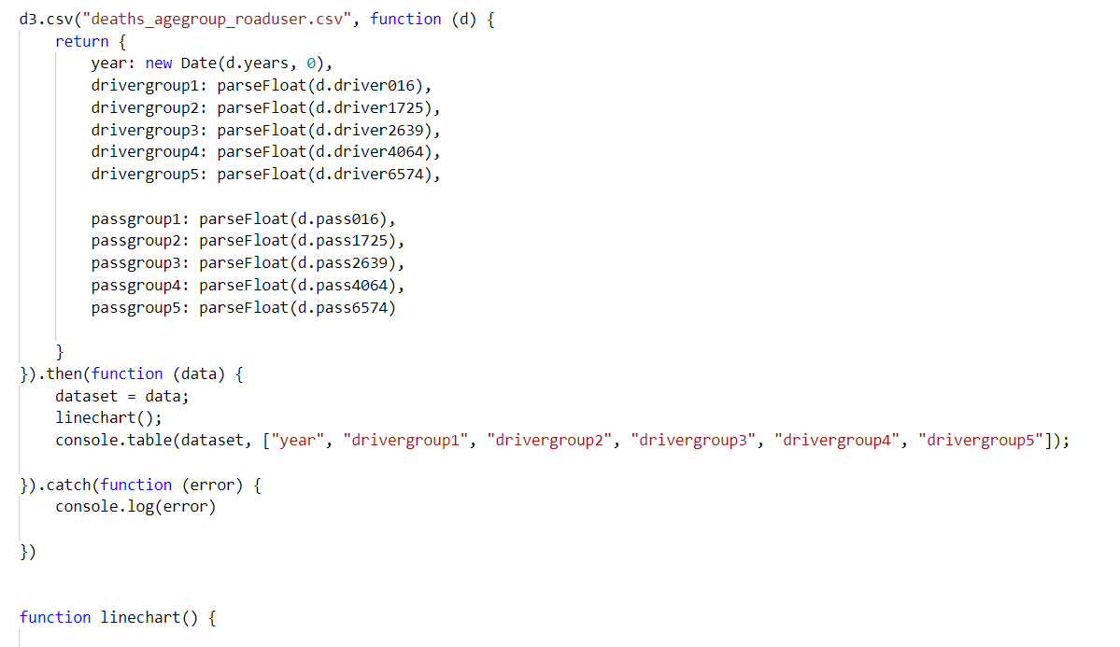

figure 5: codes for the visualisation

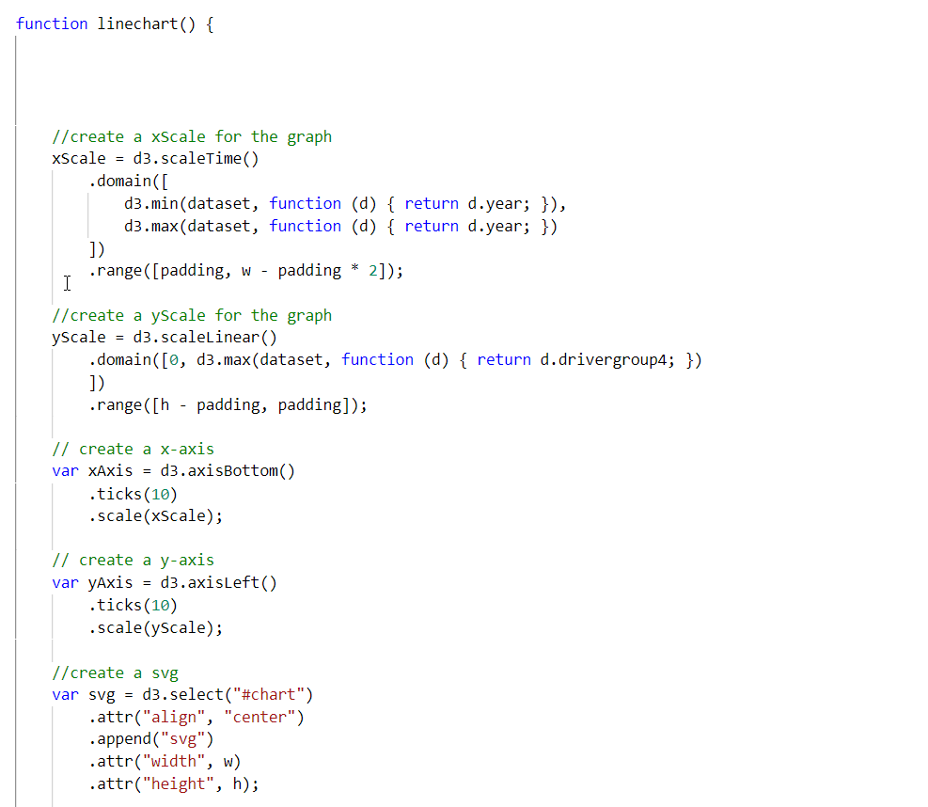

figure 6:codes for the visualisation